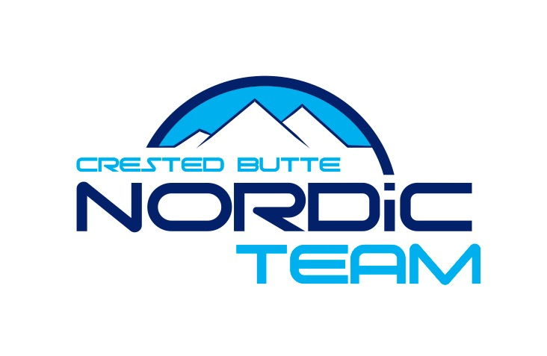

Liability & Medical Release

Assumption of Risk and Release of Liability

I understand that participation in any skiing activity, including Nordic competition (the “Activity”) involves risks of serious injury, including permanent disability, death, and other losses, both to myself and my property. I understand that these injuries and losses might result not only from my actions, but the actions, inactions or negligence of others. I agree that I am responsible for my safety while participating in the Activity and that such responsibility includes participating only when I am both physically and psychologically prepared to participate safely, after fully familiarizing myself with the venue before the event, and while using equipment of a type and condition reasonably necessary to safely participate in the Activity. Aware of the risks and willing to assume them, I hereby waive, release, and hold harmless the Crested Butte Nordic Council, Town of Crested Butte, all sponsors and each of those organization’s affiliates, subsidiaries, officers, directors, employees, agents, event organizers and sponsors, the land owners and home-owner associations, coordinating groups, doctors, officials, any individuals associated with the Activity, their representatives, successors and assigns, and will hold them harmless for any deaths or injuries suffered in connection with said Activity, including those which may be attributable to weather conditions. I intend for this waiver and release also to apply to any relatives, personal representatives, heirs, beneficiaries, next of kin or assigns who might pursue any legal action or claim on my behalf. In filling out this form, I also give permission for the use of my name and picture or any record of my participation with the Activity for publicity and/or promotional purposes. I also understand any fees I pay are non-refundable.
With full knowledge and understanding of the RISK OF SEVERE INJURY AND DEATH involved in the Activities, I FREELY AND VOLUNTARILY ACCEPT AND FULLY ASSUME THE RISK THAT I MAY SUFFER TEMPORARY, PERMANENT OR EVEN FATAL INJURIES, even if I follow the instructions or advice of CBNT.

I have read and fully understand my liability and certify my compliance by my signature below.

______________________________________________________________________________
Athlete Signature Athlete Printed Name Date

______________________________________________________________________________
Parent Signature (if under 18) Parent Printed Name Date

